**[The Effect of Increase in Foreign Reserves on Asian Economies during Financial Crises]**

**Principal Investigator: [Chen, Shiying (Christine)] ([schen484@wisc.edu])**

**Introduction**

In this project, I study the relationship between foreign reserves and the economic performance of three major Asian countries during two financial crises. Those three countries are China, South Korea and Japan and the two financial crises are 1997 Asian financial crisis as well as the 2008 global financial crisis. Do the stockings of foreign reserves reduce the volatility that economies suffer from financial crisis? Does the increase in foreign reserves help those countries suffer less during the crisis?

As part of my analysis, I draw the trend of foreign reserves since 1997 and compare the performance of the main economic indicators during 1997 Asian financial crisis and 2008 global financial crisis. I find that three countries have increased their foreign reserves after the 1997 financial crisis. For China, most economic indicators of China were less volatile in 2008 financial crisis than in the 1997 crisis. Interestingly, South Korea and Japan generate two different results. The economy of South Korea improved much more significantly during the global crisis whereas the economy of Japan seemed to perform worse in the 2008 crisis than in the 1997 crisis.

**Method**

I divided my research process in three parts. After doing some research, I defined the period of two financial crises. The Asian crisis began at 1997/07/01 and ended at 1999/12/31. The global crisis was from 2007/01/01 to 2009/12/31. First of all, I graphed the change of annual foreign reserves of three countries normalized by GDP in one plot. This graph shows if the foreign reserves have been stocked or not and how fast it has increased since the Asian financial crisis. Moreover, I graphed the monthly foreign reserve growth, quarterly GDP growth and monthly stock price changes to show the overall economy for each country. Secondly, I analyzed the economic performance of the main indicators by each country, especially comparing the volatility of each indicator during two crises. The indicators include quarterly GDP growth rate, monthly short-run interest rate, monthly foreign exchange rate, monthly stock market fluctuations and unemployment rate. The analysis was presented via statistical tables and graphs. Lastly, since every country uses foreign reserves to address different objectives, I ran regression of foreign reserves on interest rate, foreign exchange rate and percentage of closing stock prices where the datasets include data from two crises. The reason why I chose those three indicators is that they are directly related and sensitive to the financial market movement.

**Data**

All data that I collected started from 1997 to 2018. In my first part, the data that I used to graph trend of the normalized foreign reserves includes the annual GDP and annual foreign reserves dataset from World Bank. When I made graphs and conducted analysis for each country in the remaining parts, I used different datasets for each country due to the availability of data. For the monthly foreign reserves, daily foreign exchange rate and monthly short-term interest rate, the data source for three countries come from FRED. Monthly unemployment rate for three countries come from IMF but China does not have any record until 2002. The Daily Stock Prices for three countries come from Yahoo Finance. In the case of China, I gathered quarterly nominal GDP from National Bureau Statistics of China. For Korea, the dataset of quarterly real GDP comes from IMF and the dataset of Japan quarterly real GDP comes from FRED.

**Results**

In figure 1, the Asian financial crisis and the global financial crisis are highlighted in the yellow region. Figure 1 shows that three countries significantly increased their foreign reserves right after the Asian financial crisis. In particular, China’s foreign reserves changed from around 14% to more than 35% of total GDP output before the global financial crisis. Korea also increased its foreign reserves from about 5% to more than 20% of total GDP output. It seems that the foreign reserves of three countries gradually converged to about 25% in 2018, where the economies recovered from the global crisis. Based on the similar movement of the foreign reserves, it is very likely that after the Asian financial crisis, three countries concluded that the stocking of foreign reserve might serve as the precautionary role in mitigating the economic shock from the next recession, which is shown in 2008.

China

From figure 2, although the nominal GDP growth is not seasonally adjusted, it is still apparent to see that the overall economic performance during the global crisis was less volatile than that during the Asian crisis. However, it is difficult to tell whether China necessarily performed better during the global crisis than during the Asian crisis. The economic performance during the global crisis was very similar to what it was before the crisis occurred. From figure 3, other than the foreign exchange rate (3.b), the result of each indicator is consistent with what it indicates in figure 2 and is supported by the lower standard deviation shown in table 1. There are some explanations for the change of foreign exchange rate. As a country with fixed exchange rate, which is different from Korea and Japan, China successfully maintained its foreign exchange rate due to frequent intervention during the Asian crisis. Yuan appreciated significantly during in 2008 because the government pegged the yuan down to ride the economy through the global crisis[1]. The intervention of exchange rate was achieved almost purely through foreign reserves. The 0.928 adjusted R-squared in table 2 supports this claim because foreign reserve explains 92.8% foreign exchange rate. Although the adjusted R-squared is much lower for the other two indicators, the effect of foreign reserves is still statistically significant. Since the foreign reserves directly affect the fixed exchange rate, where the foreign exchange market is a big part of financial markets, the stockings of foreign reserves still helped the China economy less suffer from the global crisis.

Korea

From figure 4, it is clear to see that the Korean economy was not only less volatile but also significantly improved across all data. The economic improvement of all major indicators in figure 5 is consistent with figure 4. Real GDP growth (5.a) was more stable during the global crisis. The floating exchange rate (5.b) did not depreciate as much as it did during the 1997 crisis. Unlike 8% unemployment rate (5.c) during the 1997 crisis, the unemployment rate was well-maintained around 3.8% throughout the global crisis. The volatility of short-term interest rate(5.d) and stock market (5.e) was also smaller during 2008-2009. The statistical results in table 3 indicate that all economic indicators had much lower standard deviation during the 2008 crisis. Moreover, the regressions of foreign reserves in table 4 not only shows that foreign reserves are statistically significant at all levels but also generated fairly high R-squared for the stock market, which is the most direct indicator of the financial markets. This result supports the idea that the increase in foreign reserve actually prevented countries from further suffering from the financial crisis.

Japan

Different from Korea, Japan did very poorly during the global financial crisis as shown in figure 6, especially the stock market. The standard deviations shown in table 5 show that all main indicators from figure 7 had larger volatility during the global crisis than the Asian financial crisis. It is very interesting to see that yen experienced a sudden and sharp appreciation (7.b) when the entire economy was not doing well. Moreover, both Real GDP growth (7.a) and the stock market (7.e) dropped to the lowest point than any other period in the Asian crisis. The short-term interest rate (7.d) was close to zero at the end of the global crisis. However, it is difficult to conclude that the increase in foreign reserve is not useful in reducing the economic volatility through the financial crisis. The regressions in table 6 show that foreign reserves did not have substantial explanatory power on the indicators and the p-value for interest rate is not statistically significant. This result suggest that the Japanese government might mainly use foreign reserves for different purposes.

**Conclusions**

In conclusion, the stockings of foreign reserves reduce the economic volatility and helped countries less suffer through the financial crisis when it is significantly correlated with the financial market. In the case of China, the large stocking of foreign reserves allowed China to not only maintain the similar economic volatility before the crisis but also regulate the exchange rate to ride the economy through the crisis. The results of Korea perfectly aligned with the conclusion. At all levels, the Korean economy performed considerably better during the global crisis than the Asian crisis, partly because it was the center of the 1997 crisis. The case of Japan shows the opposite direction, partly because it was hit the most during the global crisis among those three countries and the government used foreign reserves for different purposes.

**Future Research**

To improve this research project, I think more research needs to be completed in the case of Japan, understanding why yen was largely appreciated and where the government used the foreign reserves to. Additionally, there are some data inconsistencies in this project because some data in China is not available. Moreover, the sample size in this research is too small and those three countries are very different in terms of monetary policies and as well as structure of the financial markets. In this project, I learned that the similarity of economic structures is very important to generate consistent results. For future research, I should expand my sample size, group countries that have similar structures (e.g.Korea, Thailand and Indonesia) and research into each group.

**Appendix A: Figures and tables**

Figure 1:

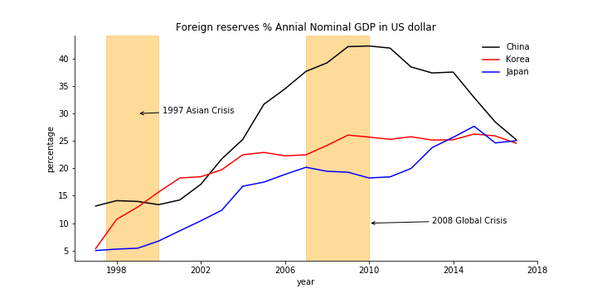

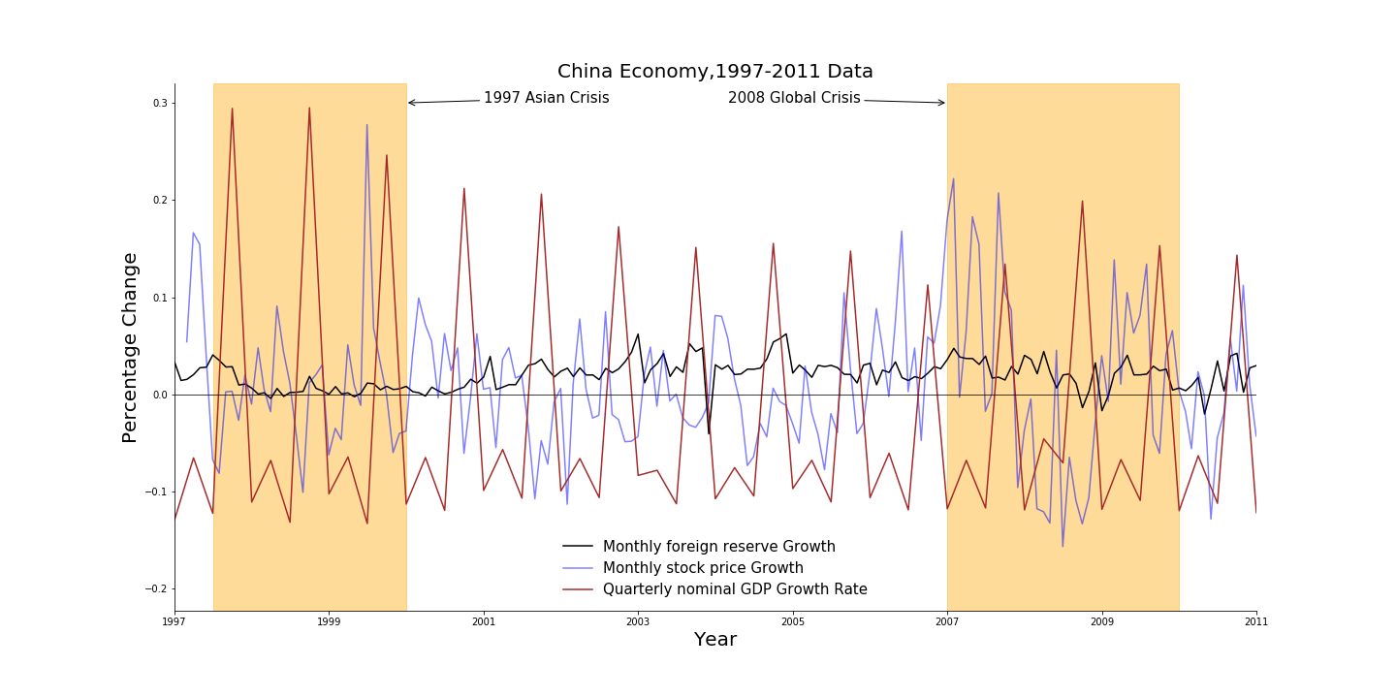Figure 2:

Figure 3(a,b,c,d):

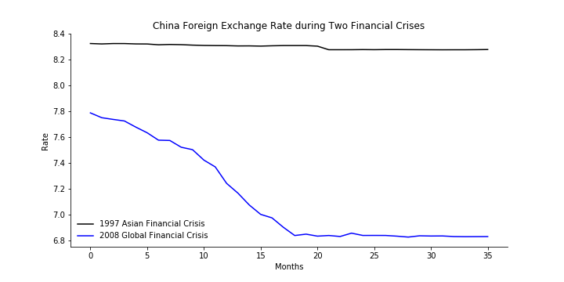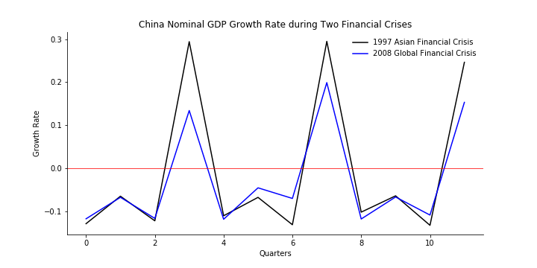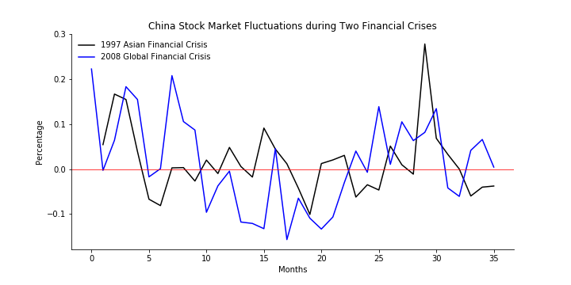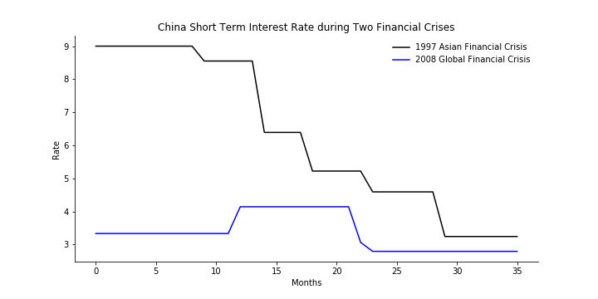3.a 3.b

3.c 3.d

Table1: Standard Deviation of China Main Indicators, 1997-1999&2007-2009

|  |  |  |
| --- | --- | --- |
| China | 97_std | 08_std |
| Nominal GDP growth | 0.174779 | 0.118618 |
| interest rate | 2.26677 | 0.545278 |
| stock market % | 0.074134 | 0.102305 |
| foreign exchange rate | 0.018972 | 0.363208 |

Table2: Regression of Foreign Reserve on monthly economic indicators, 1997-1999 & 2007-2009

|  |  |  |  |
| --- | --- | --- | --- |
| China Reserves | Coefficient | Adj.R Squared | P-value |
| stock price | 9.47E-10 | 0.418 | 0 |
| foreign exchange rate | -7.39E-13 | 0.928 | 0 |
| interest rate | -7.55E-13 | 0.078 | 0 |

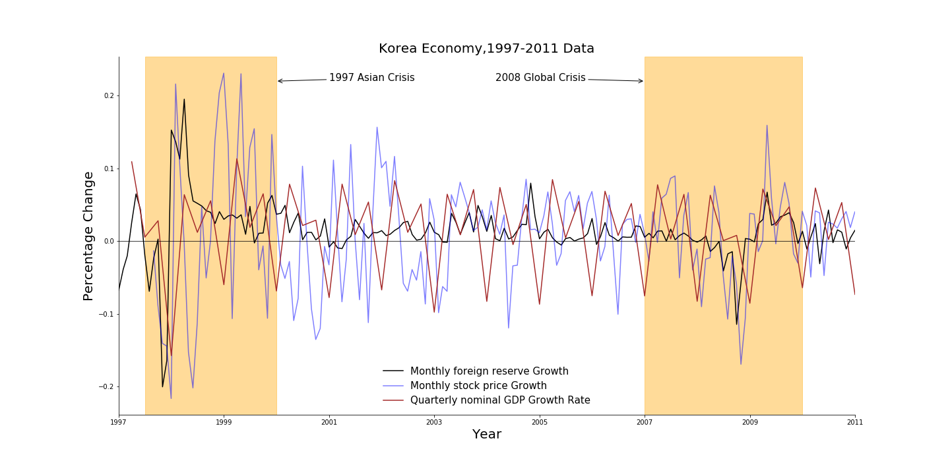Figure 4:

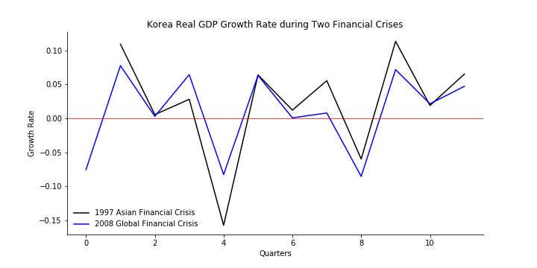Figure 5(a,b,c,d,e):

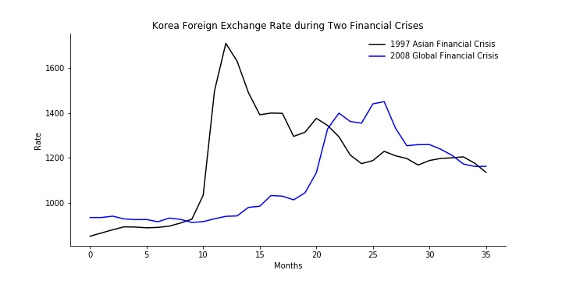5.a 5.b

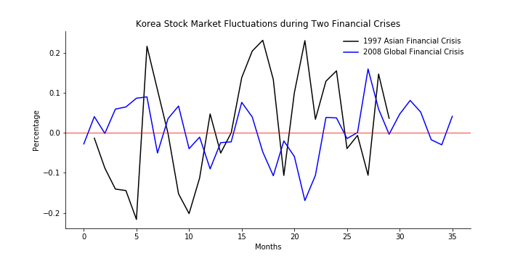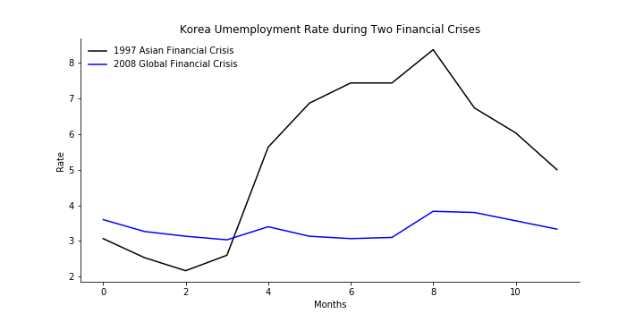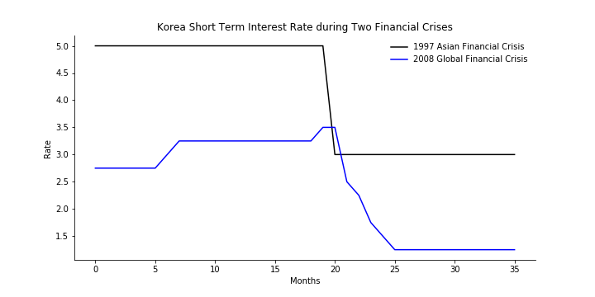 5.c 5.d

5.e

Table3: Standard Deviation of Korea Main Indicators, 1997-1999&2007-2009

|  |  |  |
| --- | --- | --- |
| Korea | 97_std | 08_std |
| Real GDP growth | 0.077425 | 0.060879 |
| interest rate | 1.007905 | 0.894067 |
| stock market % | 0.134794 | 0.066441 |
| foreign exchange rate | 225.973834 | 180.001383 |
| unemployment rate | 2.205335 | 0.284741 |

Table4: Regression of Foreign Reserve on monthly economic indicators, 1997-1999 & 2007-2009

|  |  |  |  |
| --- | --- | --- | --- |
| Korea Reserves | Coefficient | Adj.R Squared | P-value |
| stock price | 4.932e-09 | 0.782 | 0 |
| foreign exchange rate | -1.123e-09 | 0.291 | 0 |
| interest rate | -6.653e-12 | 0.325 | 0 |

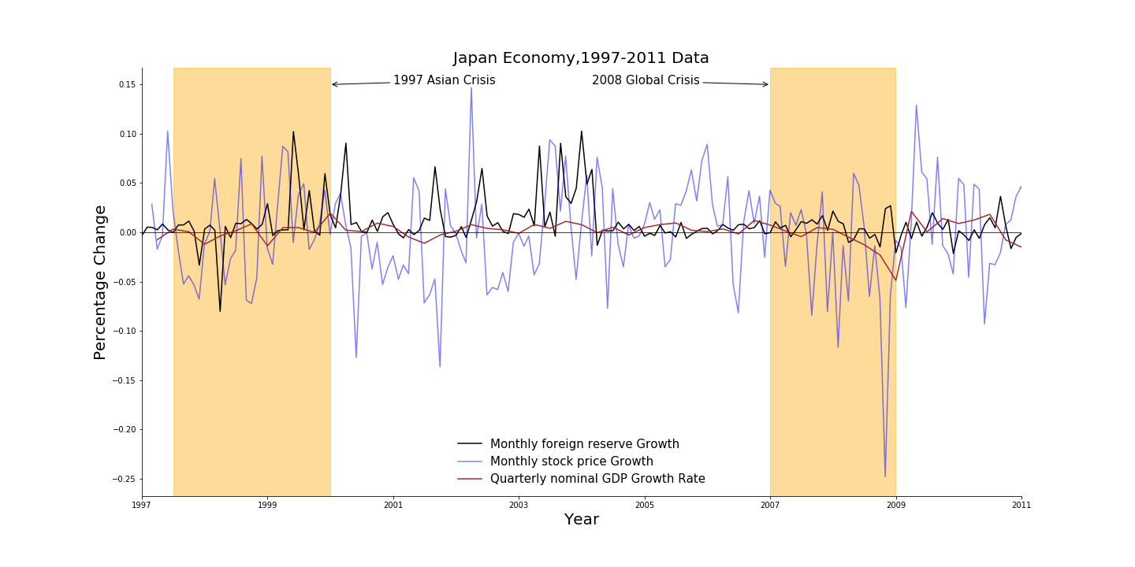Figure 6:

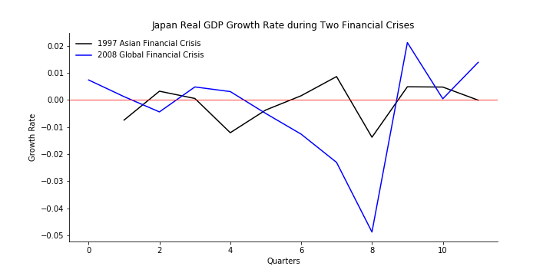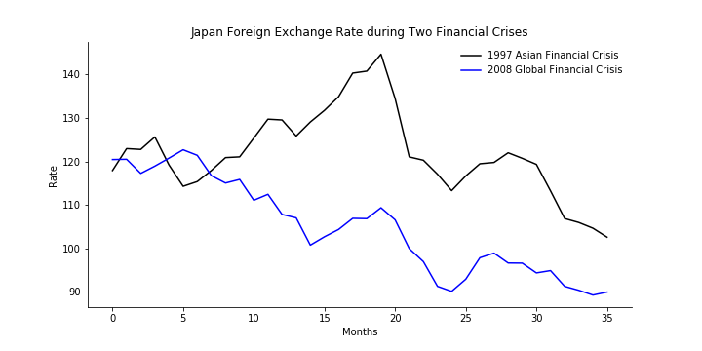Figure 7(a,b,c,d,e):

7.a 7.b

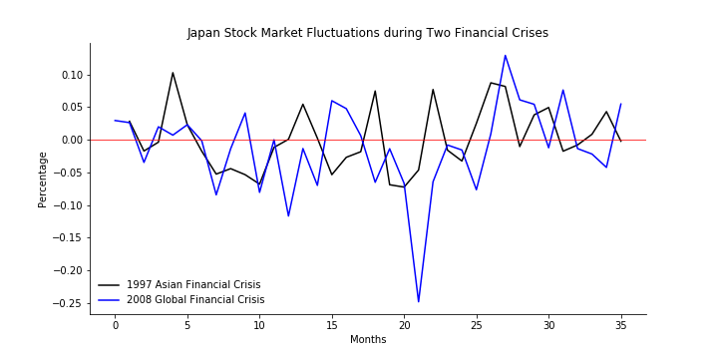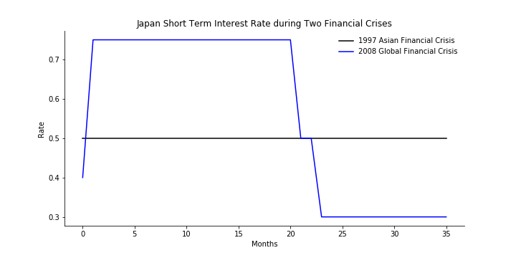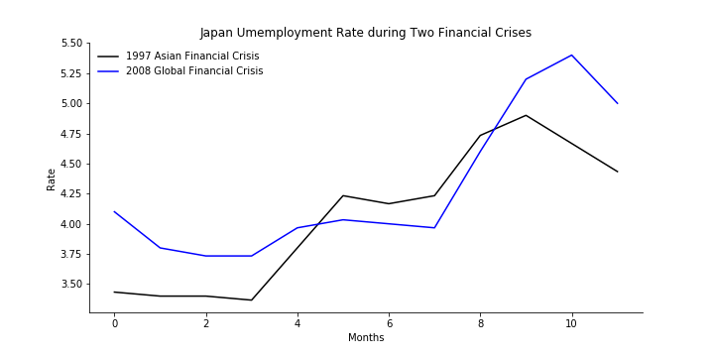 7.c 7.d

7.e

Table 5: Standard Deviation of Japan Main Indicators, 1997-1999 & 2007-2009

|  |  |  |
| --- | --- | --- |
| Japan | 97_std | 08_std |
| Real GDP growth | 0.007229 | 0.018340 |
| interest rate | 0.0 | 0.216006 |
| stock market % | 0.047821 | 0.066435 |
| foreign exchange rate | 9.809670 | 10.867026 |
| unemployment rate | 2.205335 | 0.284741 |

Table 6: Regression of Foreign Reserve on monthly economic indicators, 1997-1999 & 2007-2009

|  |  |  |  |
| --- | --- | --- | --- |
| Japan Reserves | Coefficient | Adj.R Squared | P-value |
| stock price | -4.15e-09 | 0.129 | 0 |
| foreign exchange rate | -2.124e-11 | 0.360 | 0 |
| interest rate | -3.659e-14 | 0.002 | 0.553 |

1. https://www.reuters.com/article/us-china-yuan-timeline/timeline-chinas-reforms-of-yuan-exchange-rate-idUSBRE83D03820120414